**Research report  
Javascript frame**

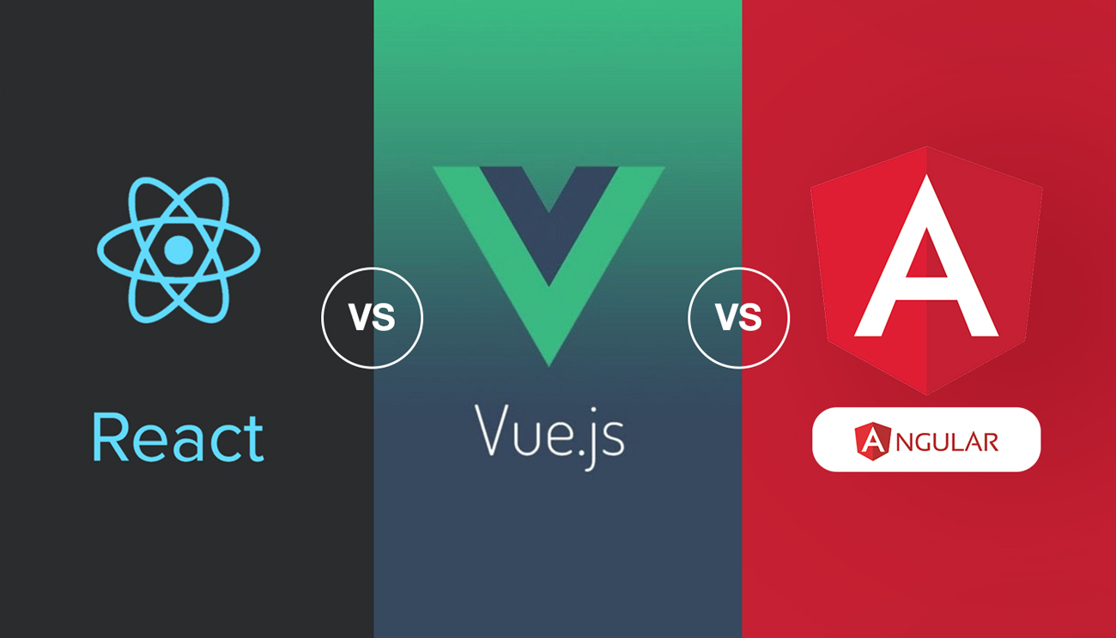

Student name: Rowan van der Weel

Student number: 4924576

Class: DB-04

Teacher: Tim Kurvers

Version: 1.0

Date: 21-09-2023

Table of contents

**Introduction** 3

Problem description 3

Main question 3

Sub questions 3

**Results** 3

Sub question 1 3

Sub question 2 3

Sub question 3 3

Sub question 4 3

**Resolution** 3

Conclusion 3

Recommendation 3

**References** 3

**Version History** 3

# **Introduction**

## Problem description

A JavaScript framework is a pre-built collection of tools and libraries that provides a structured way to develop web applications. In today’s landscape, it’s essential to use JavaScript frameworks to build the front-end of a web application. They offer pre-written code and patterns to handle common tasks, making it faster and easier for developers to create robust and efficient web applications.   
  
There are many JavaScript frameworks that exist and they keep evolving, each having their own strengths and weaknesses. The choice of a framework is very important, as it directly impacts the efficiency, performance, maintainability and scalability of web applications is impacted.

For my project “Gamify” it was recommended to use either: AngularJS, React or Vue.js for the front-end. I don’t have any insight about JavaScript frameworks, so with this research report I hope to gain a good understanding of these frameworks and determine which is most suitable for my project.

## Main question

Which of the following JavaScript frameworks is the most suitable for GamifyWork: , React or Vue.js?

## Sub questions

1. What are the strengths and weaknesses for the chosen JavaScript frameworks.
   1. **Document Analysis:** I’ll review the official documentation for each framework. Look for sections or documents that explicitly outline the strengths and weaknesses of the framework.
   2. **SWOT analysis:** Conduct a SWOT analysis for each framework. Identify the Strengths, Weaknesses, Opportunities, and Threats associated with using each framework. This will provide a structured framework for evaluating their respective advantages and disadvantages.
2. What is the level of community support and availability of resources for learning and troubleshooting for AngularJS, React, and Vue.js?
   1. **Community research:** Engage with online communities, forums, and social media groups dedicated to each of these frameworks. Observe discussions, queries, and the level of activity within these communities. Take note of the number of members, frequency of posts, and responsiveness to inquiries.
   2. **Survey:** Create a survey targeting developers who have experience with AngularJS, React, and Vue.js. Ask questions about their perception of community support, availability of resources, and their experiences with troubleshooting. Include questions about their participation in online communities, especially on platforms like Reddit. Ask if they find these forums helpful for learning and troubleshooting. Analyze the survey responses to gauge the level of support and availability of resources for each framework.
3. What security features and vulnerabilities exist in each framework?
   1. **Security test:** Conduct security testing on each of these frameworks. This may involve using specialized tools and techniques to identify potential vulnerabilities the effectiveness of their security features.
   2. **Literature study:** I’ll search for academic papers, articles, and blog posts that discuss the chosen JavaScript frameworks. Summarize the key findings regarding their strengths and weaknesses.
4. What is the level of flexibility and customization offered by each framework?
   1. **Best good and bad practices:** Research and compile a list of best practices for customization in each of these frameworks. These practices should highlight effective ways to extend or modify the behaviour of the framework while avoiding common pitfalls.
   2. **Observation:** Observe and analyse real-world applications or projects built using each of these frameworks. Pay attention to how developers have customized the framework to meet specific requirements. Document any notable approaches or techniques used for customization.

# **Results**

## Sub question 1

## Sub question 2

## Sub question 3

## Sub question 4

# **Resolution**

## Conclusion

## Recommendation

# **References**

# **Version History**

|  |  |
| --- | --- |
| **When?** | **What?** |
| 21/09/2023 | First start, initialized it and finished the introduction. |
| 28/09/2023 | Chosen different methods from the DOT framework for the sub questions. |